WHITE SANDS CIVIC ASSOCIATION, INC.
Minutes of Annual Meeting
June 9, 2022

President Deller officially calls the meeting to order at 7:00 pm.

President Deller goes over the standing meeting rules.

President’s Address 2022
In this year’s State of the White Sands Community I would like to welcome all the new neighbors to our community and thank those who have been with us for years for continuing to make our community beautiful and welcoming. Our community has stayed beautiful through the combined efforts of our mowing and litter contracts as well as our volunteers maintaining flower beds and decorating for the holidays, and I thank them for all their hard work.
I am very happy to say that community building is again being used quite frequently for rentals of all kinds. Many birthday parties, baby and bridal showers also even holiday celebrations have been held here over the last year. It’s wonderful to see the building getting so much use by the community some months it has even been rented every single weekend. I am also very glad to be able to offer Dumpster Day once again to the community and thankful for the rest of the Board members helping to volunteer their time to make this happen. This event had been on hold due to the county indefinitely stopping this service and we were unable to find another company who could provide us with the same level of service. I was excited after constantly calling for months that they told me they just started up the service again and I was able to get us immediately on the calendar. We will be having another event in the fall and hope that we can go back to this being held twice a year without any further interruptions.
We again held our annual Trunk or Treat on Halloween. I am so thankful for everyone who comes out and decorates their vehicles and hands out candy to the kids and hope we can continue to grow this event. We moved on this year to the next phase of our playground update. The old swing set was finally removed, and the new swing set was installed. There was a delay with the mulch barriers, but they were finally delivered, and we were able to get them installed last month. We are waiting on a couple missing pieces that we hope to have in the next few weeks. Our next phase this upcoming year will be to replace some damaged parts on the current older piece that was left. We will replace the damaged and missing panels and also provide a bridge of some kind to again connect the two sections. There have also been requests for some work out type items like pull up bars and such and we hope to get more ideas and come up with a play for those in the future. This year we are happy to be working on having a National Night Out Event on Tuesday August 2nd from 6-9pm. We are still looking for anyone who would like to volunteer their time for this event so that we can again hand out food items, hold giveaways and set up and clean up. Please let any of the Board members know if you are interested in helping.
This is our fourth year with Blackstone Management and things continue to run smoothly. We continue to work on recovering outstanding dues and helping our residents find a payment arrangement that works best for them. We are still receiving restitution from our former Property Manager but there were some issues that caused the Board to contact her probation officer and ask that she be held in violation. I attended the court day in May that resulted in it being rescheduled due to her new attorney not having any information regarding her court case from the previous year. In that case she requested a modification but was denied. But there is some dispute over what the judge actually said and is or is not allowing so the case was rescheduled 06/06/2022 but unfortunately that date too was just rescheduled to 07/25/2022. I will be attending that and will report the results at our August Board meeting on 08/11/2022. We will continue to work with the state attorney’s office to make sure she has paid her restitution in full by whatever means necessary.
We continue to have a Calvert Sheriff patrol our community. We actively work with him to address any concerns our residents might have. Mail tampering and possible missing packages are a current issue we are trying to resolve. We also still currently have the ATV’s and dirt bikes in our community being driven on the county roads. These are allowed to be driven only on a resident’s own property. Not on the roads, neighbor’s yards or the SMECO powerlines. The other biggest issue is parking on the roads. Vehicles must be parked in your own driveway or approved parking pads, not in yards or on the roads. We only allow limited parking on roadways if you were to say have a party, but the vehicles cannot obstruct the flow of traffic nor block a neighbor’s ability to safely pull in or out of their driveway. Nor can you park on property that is not yours. In the event you need more parking for an event than your own property can hold you can rent the parking lot of the building for the day for our daily building rental fee.
I really am looking forward to all our upcoming events and hope for lots of community participation. I really am proud to live in White Sands and I hope you all are too.

Lynda Bowman states that she would like to volunteer to help at National Night Out. Fern Yost, Robin Sizemore, and Lelia Reed volunteer to help as well.

Treasurer’s Report
Treasurer Cathy Rumenap

Attached you will find the Balance Sheet and Income and Expense Statements for Fiscal Year (FY) 2022. Because of printing requirements, these figures are accurate as of June 09, 2022.

White Sands Civic Association, Inc. has: 1183 Lots

With an annual billing totaling: $161,508.00

This year we have collected: $113,473.41 in assessments (current and past due)
$ 425.00 in building rental fees
$ 16,550.00 Restitution

Total collected in FY22: $130,448.41

Assessments still outstanding: $443,677.66

This is a number we will continue to work on improving through additional collection actions.

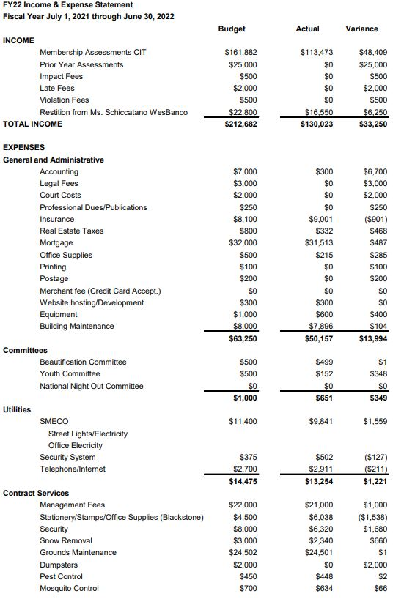

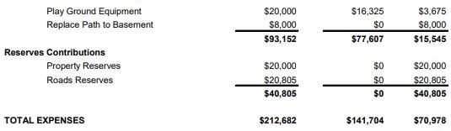

Architectural Control Committee
Chairman Becky Hilpipre read by President Deller
July 1, 2021 to June 8, 2022

The Architectural Control Committee provides a valuable and beneficial service to the community by establishing guidelines that not only conform to the Calvert County building standards, but also ensure a visually pleasing environment to our neighbors.

14 Applications this year, two of these 1 for a fence and 1 for a driveway extension were denied until other issues are first resolved. There were 3 fences and 2 decks approved. There were also 4 requests for landscaping, 1 for solar panels, and 1 for door/window replacements that were approved but did not require approval. There is also 1 request for a pool that we provided requirement information to the homeowner and that request is pending an updated request.

Covenants, Rules & Regulations Enforcement
July 1, 2021 to June 8, 2022

Starting in July Blackstone Management took over all Covenants, Rules & Regulations Enforcement. They also have a phone application that you can download to report any violations that you see as well.

65 total violations reported, with 50 of them having complied. There are 15 still outstanding, those are either new, have a hearing scheduled or are in a fineable status.

Lynda Bowman comments that she has some violations issues on Evergreen.

Beautification Committee
(Chairman Position Vacant read by President Deller)

We are still looking for a chairman to head this committee but have been so lucky for Ms. Lee and Ms. Ude continuing to maintain the plants at the entrances, signs and building as well as decorating for our many holidays throughout the year.

We are always looking for new volunteers and a resident interested in being the Chairperson on this committee.

White Sands Youth Committee
(Chairman Susan Ude read by President Deller)

This year we were lucky to get contacted by the local library who asked to begin bringing the Book mobile to the building each month. We have started offering snacks and activities in the community building to coincide with the time the book mobile is here and hope to continue this next year as well.

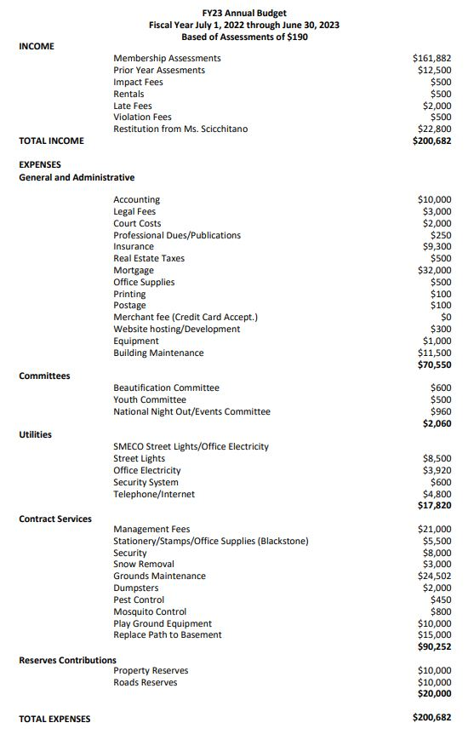

New Business
President Deller

Elections
We currently have two director’s positions to vote on. One director is up for re-election, DaNeil Deller is running again for her position, and we have one vacant director position. If anyone would care to run we will take nominations from the floor.
- Nominations from the floor.
- Jessie Sizemore
- Collection of Ballots

Ballots are turned in to be counted.

Establishment of a Quorum
President Deller does a roll call and confirms that we do have a quorum. We have 52 votes total 40 by proxy and 11 attendees.

2021 Annual Meeting Minutes
President Deller asks if everyone has had the opportunity to review the minutes from the 2021 year’s annual meeting?

A motion is made by Curt Hilpipre to accept the minutes as written this is seconded by Jessie Sizemore. The motion is passed all in favor.

New Business-
Building Rental fee- President Deller discusses the need have the building cleaned prior to rentals and how best to pay for this. There are 3 proposals.
- Curt Hilpipre makes a motion to increase the building rental fee to cover cleaning costs. This is seconded by Robin Sizemore.
- Don Goforth to keep the rental fee the same but add a cleaning fee. This is seconded by Samantha Wathen.
- Fern Yost makes a motion to have a cost comparison done. This is seconded by Lynda Bowman.

Other Business
This is the time for any resident in attendance to address issues with the Board of Directors. This period of time is open to all residents, not just members in good standing; however, the same meeting rules will apply.
- Lynda Bowman asks how often the Deputy is here. President Deller states 15 hours a month and that the days and times vary.
- Fern Yost asks if we should report dirt bike to the Sheriff. Curt Hilpipre replies yes so that we are on their radar. Lynda Bowman comments that this seems to be a problem again.
- Don Goforth comments that an empty house on White Sands Drive was found to be occupied by a vagrant.

Ballot Results-
Budget Approval- 33 for and 0 against

Elections- Director Elections
DaNeil Deller-33 for and 0 against
Jessie Sizemore-33 for and 0 against

New Business-
Building Rental fee stays same just add a cleaning fee- 32 for and 0 against

Meeting Adjourned

